Pharma Scheduler Documentation
Updated on: November 18, 2025

Core Concept
The core concept of scheduler is to create schedule (Start / End) of activity on each machine. There are many generic rules / conditions and some very specific client or plant specific rules and conditions.

The Scheduler algorithm currently has 3 flavors
- Bottleneck is already levelled (VFlow?) OR first operation itself is bottleneck.
just take each job and schedule along the defined route and dependencies
SPIMACO
- Bottleneck is very dynamic and reverse scheduling: AjantaDHJ
This is a very recent experiment. In this assignment, the bottleneck shifts from time to time and from order to order.
Here we first do a DDQ and then based on the TargetDate, assign the jobs on packing as bottleneck (option trimming) and we schedule jobs (one by one) backwards - means schedule on last packaging workstation and then move backwards. See the AjantaDHJ section and code
- Bottleneck is known but load leveling is required.
Glenmark GOA, Glenmark Indore
Here the scheduler will
  - schedule the batches on the primary bottleneck and assign specific machine if a batch has multiple machine applicable in this workstation. No schedule will be calculated
  - schedule the batches on secondary bottleneck and assign specific machine if a batch has multiple machine applicable in this workstation. No schedule will be calculated
Once this is done, the planner will check the level loading, capacity availability etc. The planner may choose to remove some batches, add overtime to ensure loading is even
Once the load is levelled, all the batches are scheduled from first to last along the defined route and dependencies (note the machine variability is removed for bottleneck machines).

Additional considerations for Scheduler:
- Scheduler generates hourly slots for all machines.
Each HOURLY SLOT will be marked with FREE, OCCUPIED or “some text” related to change overs (CO)etc.
- The scheduler will use FREE slots to schedule batches and COs
IMP: the duration identified cannot jump over existing batch or CO.
Means there are no overlapping time segments of jobs or CO’s
- Scheduler will fail is no continuous FREE slots are available to accommodate batch or CO – Planner will either add more working hours and/or add more calendar days and/or remove batches
- Between two batches there will either be a Type A CO (BCO) OR Type B CO (PCO).
- If the operation time is rounded to NEXT INTEGER as the slots are HOURLY
- Handle existing WIP in plant
Scheduler will first consider the load of existing batches scheduler / running on machine. Scheduler will replace the corresponding FREE slots with OCCUPIED
There are different ways to handle this
  - Glenmark – The planner will indicate how much days of load to PRE-book in each workstation or machine. (Example: 3 days in blending, 4 days in compression and 6 days in Filling)
  - SPIMACO & Ajanta DHJ
There is no additional need to handle this. The data contains status of all RELEASED batches and the last / current operation being performed. This becomes WIP automatically.
All the other batches are scheduled after the WIP is plotted.

  - Elements:
There are following core elements
- Job / Scheduling Entity – JOB is the minimum element that the code will assign start and end on machines along the defined route. This can be a SINGLE BATCH or group of BATCHES. Jobs can be INDEPENDENT that run from start to end of route or can be DEPENDENT. Job has following attributes:
  - Unique ID
  - FG List: List of FG’s this single job will. Example: 1 SFG goes in multiple FG’s
  - bucketID – Bucket is pool of batches based on either color priority or some criteria (example in Goa DoFC defines buckets)
  - Priority: This defines the sequence in which scheduler will schedule jobs
  - Material: SFG or FG Code – this is required to decide the type of change over between batches. Same material will have type A/Batch CO while different materials will have type B/Product CO.
  - Sequence: Routing sequence at workstation level
  - predecessorJobs: If the job is linked to another job.
E.g. FG job will have dependency on one or more SFG jobs.
A SFG job may have dependency on common blend or bilayer or multilayer
  - attributes – Some attributes that scheduler may need (e.g. SFG Name)
  - machine_affinity – This is the list of applicable machines in a workstation for this job. All the workstations defined in “Sequence” must exist
  - processing_times: This is the time defined for an operation on one machine. All machines defined in “machine_affinity” must have time defined here
  - campaignID & campaign : Optional: If multiple jobs are to be clubbed.
  - isCommonBlend: If this job refers to common blend. This was used in Goa to define dependency. However later assignments handled this through “predecessorJobs”
SPIMACO & AJANTA: a JOB is defined as ONE BATCH.
GOA & INDORE: JOB is one SFG commit which contains multiple batches

- Campaign: (Do not confuse with TOC concept of campaign) - OPTIONAL
This is a collection of jobs that will be processed one after another to ENSURE same machine is used to reduce Type-B/Product Change-Over. For creating campaign, the ROUTE of all jobs MUST BE EXACTLY SAME
AJANTA: Multiple Orders are collected to form campaign (limit of MAX 6 orders)
SPIMACO & GOA & INDORE: Not used
- Machines and Workstations:
Machine is an independent entity on which a JOB will be scheduled.
Workstation has set of machines assigned. For now, a machine can be part of only ONE workstation. Machine has following attributes:
  - Id: This is a unique machine code. In case of SPIMACO it’s the TCode. In other assignments its defined as M01, M02….so on
This ID must be same as the one used in JOBs machine affinity and processing times.
  - Name: Readable name (just used for report)
  - ChangeOver times:
    - typeA hours
    - typeB hours
    - SWAB hours
  - isTimeBuffer & timeBufferHRS : IMPORTANT (not T33OC Buffers, referred as QCBuffer): Some operations are like CURING operations. They are part of sequence. They do not require time scheduling. However the job needs to wait for the designated time (timeBufferHRS)
Example: QC in Ajanta. It’s a 48 hour process. They DO NOT need schedule for this. However between previous operation and next operation, there needs to be GAP of hours defined here
  - Group: (Optional) This was initially discussed for Goa where it’s EASY to define ROUTE with multiple machines
Machine can be part of a groups
e.g. You can define a group L1 and assign Legacy-1, Legacy-2, Legacy-5 machine
However all other clients use an easier way to assign multiple machines.
Example: “Blender-5/8/9/11” – which means ANY ONE of 4 blender machines can be used
- Transfer time (referred as Buffer Time) between 2 operations: OPTIONAL
In some environments, once the operation is finished on one machine, you need to leave time gap for next machine. This is a transfer time defined between workstations. Example: Between Granulation and Blending leave 12 hours gap
AJANTA: 24 hours
SPIMACO & GOA & INDORE: Not used
- Capacity Calendar: For every machine, there needs to be a definition of working hours. Different machines will have different working hours across different days
e.g. A machine works 3 shifts a day from Monday to Friday, 1 shift on Saturday and not working on Sunday. In addition, will have preventive maintenance at specific time
GOA: All machines work 3 shifts a day EXCEPT Sunday
Indore: All machines all shifts all days
Ajanta & SPIMACO: These assignments have defined an excel file that shows daily working hours for next 2-3 months. This includes any planned downtimes
Example:
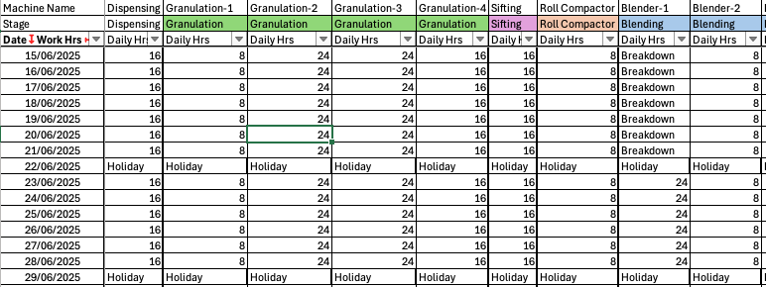

The above Calendar gives complete control on machine availability over horizon
- Routes and Timings: A job moves from one machine to another from 1st operation till last operation based on the route defined in masters.
IF SFG is common blend / bilayer etc, then it will contain partial routes
IF SFG is dependent on another SFG (Bilayer or Common Blend) then the route will be defined not overlapping the dependent SFG’s route
FG operations will have only 1 operation (with different machine options)
Example: Routes in Ajanta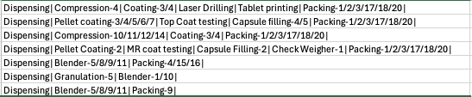
Routes in Indore
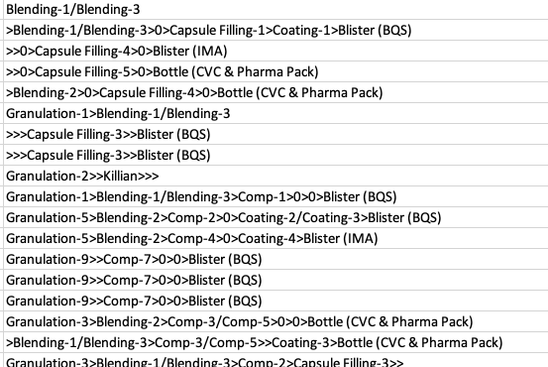
Routes in SPIMACO
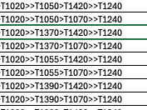

How stuff works
- Scaffolding of the core scheduler algorithm

The Scheduler takes 4 inputs
- Jobs (batches or campaigns)
- Machine Master
- Time buffers between operations (if defined)
- Capacity Calendar (if provided)

- The scheduler starts with reading the Jobs and Machine master.
It validates if the machine master has any discrepancies. Then it validates if any job has machine defined which is not part of machine master (this is redundancy as this validation is also part of Data Importer)
- Next it generates hourly slots for each machine (no slots are generated for machines defined as TIME BUFFER only)
If there is a capacity calendar given then the hourly slots, then slots are based on the capacity defined
If the capacity calendar is not given then Scheduler needs shifts per day and holiday / weekend list.
- Generate all possible routing paths for all jobs. Imagine this like project plan tasks dependency
- For sites requiring bottleneck leveling, calculate the load of jobs on each machine that DO NOT have variation on defined bottleneck
Example: Say Compression has 4 machines. Identify jobs that have only 1 machine in Compression. Machine wise sum the load
- Bottleneck Orchestrator (Site Specific / Glenmark) – Repeat for each bottleneck specified
  - Find all job passing through this bottleneck
  - If specified, sort the jobs with defined criteria.
e.g. Glenmark GOA – first sort orders if they are Blister Packs, then sort by single machine in Compression, then Granulation, then DoFC
For SPIMACO – use the VFlow BPP
  - For each participating machine, identify the start and end time based on the FREE hourly slots.
  - Block typeA / typeB CO’s
  - Select the machine which has
    - Earliest Start
    - Less load (calculated in step 4 above)
  - On the selected machine, reduce the calculated load by touch time of this job on this machine
Also mark the time slot on the selected machine as OCCUPIED-Jobxx
  - If the job had more than 1 machines available, replace them by selected machine
  - Take next job and go to step 5c till all jobs on this bottleneck are over
  - Repeat this entire process for other bottlenecks
- Main Orchestrator (Site specific): Here we will schedule all jobs
For different sites, you can have different ways to orchestrate
Option1: Schedule a job from first operation to last operation
Option2: Schedule all jobs on first operation and then keep moving till last operation (For this operation sequence at workstation level MUST be same for all jobs e.g. Granulation->Blending->Compression->Coating/Filling-> Packing. Also, CANNOT have jobs having same operation twice)
Option 3: Combination of 1 and 2 – some jobs take option1 while others take option2. Example: SFG’s will do option1 and FG will do option2 (Probably Glenmark Indore may be configured this way – one SFG goes in multiple FG’s AND multiple SFG’s can go in SINGLE FG)
Caution: The two set of job’s cannot share the workstations – meaning if Option1 contains Granulation->Blending->Compression and Option 2 contains Coating/Filling-> Packing this can be used. If there is an overlap DO NOT TRY USING THIS.
The main consideration for this choice is HOW the jobs are defined versus individual batches. E.g. in SPIMACO each SFG batch is tied to FG so using Option1
  - Option 1 “loop” – 3 passes
There are cases where gaps will get created due to arrival time on subsequent operation. This MAY be an issue in some assignments (e.g. Glenmark GOA where one job has 8 batches and other with lower priority has 1 batch). In these assignments, we may temporarily reject a schedule and sequence the job later to give opportunity hence the two passes.
Ajanta / SPIMACO do not have this problem.
    - Take available job from the priority sorted list (ignore failed jobs)
      - If you are in 1st PASS, then set the ACCEPTABLE FREE SLOTS to some number (say 12 hours for Glenmark Goa)
      - If you are in 2nd PASS, then double then ACCEPTABLE FREE SLOTS
      - If you are in 3rd PASS, set the ACCEPTABLE FREE SLOTS to ZERO (0) – this check will NOT be performed – this is the final chance for job to be scheduled.
    - Get the Core Scheduler algorithm to try and schedule the job across all possible paths.
    - If any of the operation fails on any machine in sequence (when no Free slots are available), then flag this job as FAILED.
    - Try to pick the best path (this is site specific).
Glenmark: check for path with earliest start and minimum free slots and less than ACCEPTABLE FREE SLOTS.
Ajanta/Spimaco: check for path with earliest start and if same earliest finish
    - If the path is selected, then mark the path, record the data and mark this job as SUCCESS.
    - If the path is NOT selected due to any criteria, then flag the job as RETRY
    - Continue till all jobs are done and all PASSes are completed.
  - Option 2 loop – EXPERIMENTAL - NOT USED
This was an experimental thought – not implemented in any assignment.
Here we loop from first operation till last operation.
    - Take available job from the priority sorted list (ignore failed jobs) for ONE operation
      - If you are in 1st PASS, then set the ACCEPTABLE FREE SLOTS to some number (say 12 hours for Glenmark Goa)
      - If you are in 2nd PASS, then double then ACCEPTABLE FREE SLOTS
      - If you are in 3rd PASS, set the ACCEPTABLE FREE SLOTS to ZERO (0) – this check will NOT be performed – this is the final chance for job to be scheduled.
    - Get the Core Scheduler algorithm to try and schedule the job on this workstation – This algorithm will check the arrival time from the previous operation
    - If any of the operation fails on any machine in sequence (when no Free slots are available), then flag this job as FAILED.
    - Try to pick the best MACHINE (this is site specific).
Glenmark: check the machine with earliest start and minimum free slots and less than ACCEPTABLE FREE SLOTS.
Ajanta/Spimaco: check for machine with earliest start and if same earliest finish
    - If the machine is selected, then record the data.
    - If the machine is NOT selected due to any criteria, then flag the job as RETRY. Ignore if any previous machines are selected
    - Continue till all jobs are done and all PASSes are completed.
    - Move to next operation in sequence and loop

  - Option 3
This is a combination of 1 and 2 above. Look at Ajanta DHJ code on how to implement this.
This completes overall structure of the flow.
In the next step we explore the heart of the algorithm

How stuff works
- Deep dive into core scheduler algorithm

The main component of the algorithm is to find the schedule for an operation of a job. There are many variables and constraints to be solved.
Here we are going to operate on a single job irrespective if its common blend, bi/multi-layer, FG only or end to end.

The result of this module is SUCCESS, FAILURE, RETRY.
In case of success, record the data (we will see this in detail)
Let’s consider the following as example
(M1, M2) (M7) (M15, M16, M17, M18) (M8, M9) (M45, M55) (M11, M12)
Granulation – Blending – Compression – Again Blending - Coating – Packing

- Get all the paths for the job. The typical paths would be
Path1 - (M1) (M7) (M15) (M8) (M45) (M11)
Path2 - (M1) (M7) (M16) (M8) (M45) (M11)
...
Path 10 - (M2) (M7) (M18) (M9) (M55) (M12)
...
and so on
- For each path, get the sequence of steps (machines)
If orchestrator is end-to-end, we have 6 steps (M1, M7, M15, M8, M45, M11)
If orchestrator is processing single operation, take the steps for this operation.
e.g. if Compression then we have only 4 steps (M15, M16, M17, M18)
- For each step we need the machine, touch time, hourly slots for the machine, changeover times, buffer time (if specified), previous step data
If this is the first step then check if this job depends on another job (e.g. common blend). This will be the previous step data
Run the following loop for all steps
- Get the starting time based on Previous STEP.
If this is first step of the path and no dependency, then job can TECHNICALLY start first hour of START_TIME
If there is a dependency then finish time of previous step + buffer time is first possible START_TIME
If the batch size is more than 1, we need to handle Transfer Batch timings. We do not want the current operation (starvation) to wait in middle if the earlier operation is fast or slow.
Here is the example: Say touch time per batch for previous operation is 12 hours and current operation is 6 hours. And there are 5 batches. If we transfer 1 batch at a time
This is how problem, can be solved. In this scenario we need to DELAY the transfer of Batch1so that there is no interruption. In the case below the transfer happens at the end of Batch3 on previous operation
If the previous operation is fast, then next operation can start as soon as First batch is finished. Adjust the start time accordingly. This time will be the earliest the batch can be scheduled (EARLIEST START TIME)
- If the current STEP is a QC type Time Buffer only (like QC in AjantaDHJ) then we just add time associated with this to the end of previous step and assign the start and end of this step and go loop back to processing next step/machine
- Here we try to find the 1st available continuous slot.
  - Option 1: If the machine is free (no jobs scheduled so far), its simple.
For each batch
  - Search for the 1st FREE slot on or after the EARLIEST START TIME
  - Collect free slots equal to the touch time of one batch
  - Collect free slots at the end of the Add a type A CO / BCO
If there are NO free slots, flag the job as FAILED and exit
Record the start and end of each batch and each CO,
As there are no previous jobs on this machine, the FreeSLOT count is 0
Loop back to processing next step/machine
  - Option 2:
Find the job before and after the EARLIEST START TIME. Let’s call them Prev-Job and Next-Job
We have following cases:
Case 1: There is a Prev-Job but no Next-Job
Schedule the CO first (CO can be typeA or typeB depending on the SFG/FG code of Prev-Job) and then batches and their own typeA CO in between.
If the slot with FREE status is less than required time, flag the job as FAILED and exit
Record the start and end of each batch and each CO,
As there IS previous jobs on this machine, calculate the FreeSLOT between two jobs
Loop back to processing next step/machine
Case 2: There is no Prev-Job but Next-Job exist
Schedule batches and their own typeA CO in between. Then schedule the CO between this and the next (CO can be typeA or typeB depending on the SFG/FG code of Next-Job)
If the slot with FREE status is less than required time, flag the job as FAILED and exit
If the end of last CO is AFTER the start of the Next-JOB, we do not have enough gap. Set the EARLIEST START TIME to END of Next-Job, go back to finding slots
Else, record the start and end of each batch and each CO,
As there are no previous jobs on this machine, the FreeSLOT count is 0
Loop back to processing next step/machine
Case 3: There is a Prev-Job and Next-Job with gap in between (may not be free)
This is tricky – there will ALREDY be a CO between Prev-Job and Next-Job, so we need trial-and-error loop.
Locate the start and end of CO between Prev-Job and Next-Job
Calculate the schedule of batches and their own typeA CO in between.
If there are NO free slots, flag the job as FAILED and exit
If the start time of batches is after the existing CO, check if we can fit a CO between this job and Next-Job.
If we cannot, Set the EARLIEST START TIME to END of Next-Job, go back to finding slots.
If we can fit, record the start and end of each batch and each CO. As there IS previous jobs on this machine, calculate the FreeSLOT between two jobs
Loop back to processing next step/machine
- If we don’t have any failures means we have at-least 1 path.
- If there is only 1 path, this IS the BEST path. Select this path, update the data structures with the start and end of each batch and COs. Record the end of last step as the ARRIVAL TIME for dependent jobs (if any)
- If we have more than 1 path, apply SITE specific logic to select the best path. The logic can be any combination of earliest start, earliest finish, total free load, total lead time from start to end etc. etc.
For the selected path, update the data structures with the start and end of each batch and COs. Record the end of last step as the ARRIVAL TIME for dependent jobs (if any)
- We are done. Next job….

Source Code – Available on VDL Devops GIT Repository
https://devops.vcgdigital.net/VectorDigitalLabs/Glenmark_Prod_Scheduling/_git/Glenmark_Prod_Scheduling

Tech-stack:
Python 13 (Standard python dependencies)
Special module Dependencies:
bisect, sortedcontainers, pandas, numpy, ABC, abstractmethod, xlsxwriter\
Important: there are no 3rd party modules used for CORE scheduling algorithm to avoid any external dependency

Python Expertise Requirement:
- Medium to Expert
- Must know dataframes and PERFORMANCE issues with dataframes
- “Vectorized function” to handle complex operations for performance gains
  - E.g. Vectorized bucketing with np.select

Overall Technical Structure:
There are three main components
- Campaign Generation module
- Scheduling module
- XLSX Report Generation

Folder | Files | Description
CoreScheduler | CoreScheduler_v1.py | This file contains majority of the code for the algorithms across Glenmark, Spimaco, AjantaDHJ  Any site specific requirements (e.g. select best route or calculate single machine load etc.) is handled in respective implementations
AjantaDHJ | AjantaDHJProcessInput.py  (Campaign Generation module) | Reads data and master files and generates 3 files that Scheduling Module uses (jobs, buffers, machine master)  Also manages machine wise Capacity Calendar
 | AjantaSchd.py | This is Ajanta specific customisation that uses CoreScheduler
 | AjantaDHJGenReport.py | Generates Final Schedule output
 | DHJconfig.py | Define all file paths here
Glenmark  (For Goa) | comitted_batches_xls.py  (Campaign Generation module) | Reads data and master files and generates 2 files that Scheduling Module uses (jobs, machine master)
 | GlenmarkGoaSchd_v1.py | This is Goa specific customisation that uses CoreScheduler – including Bottleneck level loading before scheduling
 | genReport.py | Generates Final Schedule output and Machine Occupancy reports
GlenmarkIndore | GlenIndoreProcessInput.py  (Campaign Generation module) | Reads data and master files and generates 2 files that Scheduling Module uses (jobs, machine master)
 | GlenmarkIndoreScheduler.py | This is Indore specific customisation that uses CoreScheduler – including Bottleneck level loading before scheduling
 | GlenIndoreGenReport.py | Generates Final Schedule output and Machine Occupancy reports
 | genReport.py | Generates Final Schedule output
Spimaco | spimaco_db.py | Fetch data from VFlow using SQL queries
 | spimaco_FTP.py | Fetch files from FTP server
 | ProcessInputs.py  (Campaign Generation module) | Reads data and master files and generates 2 files that Scheduling Module uses (jobs, machine master)  Also manages machine wise Capacity Calendar
 | Spimaco_Scheduler_v1.py | This is SPIMACO specific customisation that uses CoreScheduler
 | genReport.py | Generates Final Schedule output
 | DHJconfig.py | Define all file paths here
data | This folder contains JSON file generated my site specific Campaign Generation module  It typically contains following files  * Jobs.json - entity that will be scheduled (batch or campaign)  * buffers.json – if there are any interstage buffers these are defined in this (e.g. AjantaDHJ)  * WS.json – This is the workstation and machine master
.venv | This is python’s virtual environment
ROOT Folder | Contains 2 PYTHON specific files –  .gitignore  Requirements.txt
All Other Folders | They appear for historic reason during initial experiments and test cases. Can be SAFELY IGNORED or DELETED  Example: “code_archive” or “.vscode” or “Logs” etc

Ajanta DHJ (New Experiment with DDQ and reverse)
Masters:
- Capacity & CO Times (DHJ-CapacityCalendar.XLSX): This shows the machine wise capacity and change over times. There are some machines that are marked as TimeBuffer. They do not need schedule. Just need to create gap between previous and next operation
- Parent-Child Mapping (DHJ-CapacityCalendar.XLSX): This shows the batches feeding to another batch (like common blend into SFG)
- Modified Route with QC.XLSX: The route master given to VFlow do not contain QC operations (time buffers). These routes are mentioned in this file. Overwrite the routes in the original route master
- Trailing Department.XLSX: This is the mapping between trailing dept in the daily input file and the state in scheduler
- DHJ Product Route (Unreleased Batch Status.xlsx(from SAP) – note the space in filename): This is the main route master that is available in SAPInput given to VFlow.
As this file contains other data, the location of this file is NOT in MASTER but in INPUT
- Load Master (Load sheet in BPR Status.xlsx – shared manually): This shows the capacity to be used for DDQ. This file is updated occasionally. Current location is INPUT folder (can be moved to MASTER)

Input:
- Released orders - OverallBMReport.csv (from VFlow MTO DHJ output folder) -These are released orders with trailing dept.
- Unreleased orders - UnReleasedBatchStatus.xlsx (note filename without spaces & from VFlow MTO DHJ output folder) - These are orders yet to be released

Path Configuration (DHJconfig.py)
All the PATHS for files are defined here.

Input data processing (AjantaDHJProcessInput.py):
Here we capture all inputs and generate JSON/parquet files for Scheduler
- Get Machine / Workstation data: First 6 rows of Capacity & CO times define machine and workstation details, and remaining rows is daily working capacity
Save the row 6 onwards as dataframe (parquet) to be used by scheduler for generating hourly slots
- Read unreleased orders & Released orders:
Merge the two dataframes to give complete list of batches to be scheduled
Scheduler to schedule released orders first and then unreleased. There are two main buckets - released and unreleased.
- Read the main route master and QC modified route master
  - Validate the files
  - Overwrite the entries in main route master with QC values (if present)
  - Remove If any duplicate entries
  - Convert the string route to list of machines and touch time. (List of list of tuples)
  - If any machine is missing or has invalid touch time, flag that route as error
- Add routes to the merged order dataframe
If any batch has missing route or route has error (invalid time etc), remove the batches
- Based on the trailing master update the trailing dept in orders with stage mapping
Handle IMQC trailing dept (as QC is not an operation but just a time buffer). If any IMQC code is not part of trailing master, show an error for master correction
- Drop all batches that are COMPLETE – don’t need to schedule these
- Fix the batches route based on trailing dept. If the route starts from Granulation while trailing dept is Compression, drop the operations till Compression
This will be our NewRoute. Also generate the workstation sequence (this is not important for scheduler in case of AjantaDHJ
- Find if same SFG+FG has different routes or machines
If yes, we have to drop these batches
- Find bad batches: As there are multiple rows with same batch number, we need to identify following:
Batch having multiple SFG that are not common blend - OK
Batch having multiple common blends without FG - Problem
Special Batches – BiLayer or MultiLayer (multiple SFG’s going into single FG)
- Before creating campaigns, increase the priority of HOLD TIME impacted orders:
This is only for released batches. If the hold time for a batch, is within next 5 days then they must be processed first. The way to do this is INCREASE the BPP to MAX
- DDQ: Understand the DDQ module (excel based) from DHJ team – Kiran Vaykar
We will replicate the excel method. Take the order and for each operation calculate the load on machine group specified in routing. Find the operation with highest load. THIS is bottleneck for THIS order. Take the current FOL (zero for 1st order), add the current load of this order and apply % of buffer depends on what stage the order is currently in. This is the TargetDate. Packaging operation will HAVE finish at this time. Then for this bottleneck add this load to FOL for subsequent calculations
- Club the batches of same SFG together in 15 days window, to form a campaign to reduce typeB changeovers. There may be a single SFG with different trailing dept. We cannot club them together. Generate a unique route id to differentiate this
- Group orders by 'Bucket1','Bucket2','SFGCode', 'NewRouteStr' and generate a campaign ID. Important: A campaign can contain only MAX_BATCH_SIZE (6). Means if there are 8 batches of same SFG in same bucket and same CAMPAIGN horizon, then there will be two campaigns of 6 + 2
- One batch can go in multiple FGs, so the SFG needs to be scheduled only once till packing. So, drop the duplicate rows and keep only 1
- Update the batch dependency based on Parent-Child mapping
- Do the DDQ (this is last minute change) – very similar to VFlow DDQ (get details from Ajanta team)
- Inter stage Buffers: Ajanta needs time gap between two operations.
- Generate the JSON files for Buffers, Jobs and Workstations
- Save the Campaign file (for debugging)

Scheduling (AjantaSchd.py):
First, we allocate machines on bottleneck (Packing is the bottleneck at the time of writing this document) and then we schedule all operations in reverse.
Here are the steps (starting with main function)
- Import the JSON files and the calendar parquet
  - Generate the hourly slots
  - Populate list of jobs and buffers
  - Verify the machine affinity in job has machine details in workstation data
- Instantiate Ajanta specific scheduler.
- Generate paths and read the calendar only for bottleneck (packing)
- Then in “_packing_orchestrate_opt_v2” we orchestrate to allocate machine for each job. This is done in core scheduler function “_schedule_job_on_all_ws”
- Save the machine affinity for modified jobs in a JSON
- Generate ALL paths for each job in a dataframe
  - Start date as today
  - Horizon is not required as the capacity calendar will define this
- Schedule jobs using “schedule_opt_v2”
This function calls orchestrator (_orchestrate_opt_v2) category by category (remember there are 2 main buckets – released and unreleased)
- Orchestrate jobs using “_orchestrate_opt_v2”
  - Get all the jobs in the bucket being processed
  - There is only SINGLE PASS – no free slot gap concept.
  - Create a temp copy of machine intervals, machine_job_map and convert the machine_intervals to dataframe
  - Call the function “_experiment_reverse_schedule_job_on_all_ws” (in the same file – currently not moving this to core scheduler)
  - Mark failed job and continue with next job
  - If the job is part of the campaign (except bilayer campaigns), then
    - Get the machine allocated to each operation
    - For other jobs in same campaign, remove all other paths (this is to ensure we process the campaign on same machines)
    - Do this only for the 1st job in the campaign
- Scheduling function “_experiment_reverse_schedule_job_on_all_ws”
This function is currently experimental. After testing this can be moved to CORE scheduler class
This function currently does not handle CO’s between jobs – This is a TODO for VDL team
  - Get all the paths and steps (PATH is sequence of operations and STEP is each individual operation)
  - Get the list of successor jobs and TargetDate for this job (calculated during DDQ)
  - For each path get the steps in reverse (starting from packaging all the way till first operation)
  - Loop for each step
    - Get the processing time (touch time), typeA / typeB / Swab hours
    - If this operation (step) is a TimeBuffer, then just SUBTRACT the qC time and record start and end and process the next STEP
    - If this is the packaging operation (1st operation in reverse) we will schedule this operation as FORWARD scheduling – all other operations will be REVERSE scheduled
    - If first STEP, then take the start of last step and subtract the inter-stage buffer. Else get the start time of the successor jobs and subtract the inter-stage buffer
    - Currently this is NOT handling CO’s so prev-next job is just calculated but not used
    - If the machine of the STEP has no jobs then just schedule the batches. Else (for now) do the SAME i.e. schedule the batches only
    - If the “_schdJobBatches” function fails to find the any continuous slots with FREE status, it will return NONE. This indicates failure of the PATH and not the JOB. If path fails, look for next path
    - Record all the data related to this step. Save the current step as prevStep and start of job as _lastStTime
  - Once all the PATHs are processed, select the best path (_selectScheduledPath)
  - If there are no feasible paths the JOB FAILs now
  - If there is path, record the data of the selected PATH so that it’s visible to next jobs
- Export the data for report generation – this is interim output

Report Generation (AjantaDHJGenReport.py):
Here we generate following outputs
- Final Calendar Schedule
- Batch wise summary
- All PATH & STEP details (for debugging only)

Final Calendar Schedule
Read the capacity calendar and identify machines that are in packing (remember 1 SFG can go into multiple FG’s)
Read the attributes required – we generate a map of BATCH and attributes for easy reference and lookup performance (_attribMap)
Read the scheduler generated output (FinalSchedule.parquet)
- This contains machine ID’s as columns and hourly slot as Index
- Curate the data by replacing the text with readable stuff
  - E.g. extract the batch number from “occupied” slots
  - Replace 'Non-Working” with “*~~*” (for excel conditional formatting)
- We need to aggregate hourly slots to shift wise (8 hour shifts). This is done by function “generateGrouping”. Here the entire hourly dataframe is converted to shift wise output. All the duplicate entries will get convered to single. Here is a sample of what is happening (let’s take one machine Granulation-1)

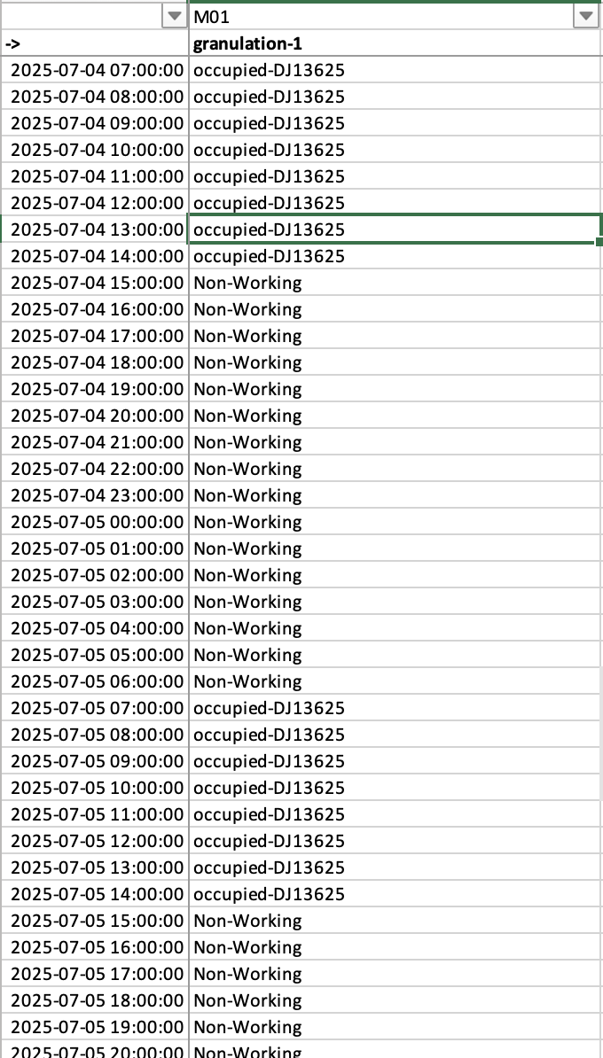 |  | 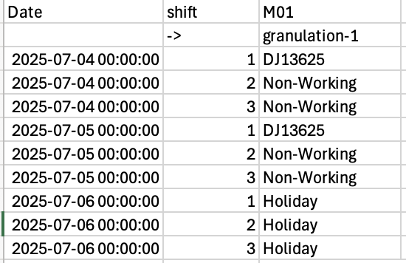

- Add the machine names (in addition to the machine ID’s) at the top of dataframe
- Update the text in columns to the one specified. This is done in “updatePCO”
- Change TypeB to PCO and TypeA to BCO
- Replace the batch number by attributes
Product Name | Batch Number | Trailling Dept | Target Packing Date | Colour | SO Number
- The Calendar OUTPUT is ready

Batch Wise Summary
This is how each batch moved between operations. Now it’s important to know the sequence of columns may not align perfectly. Here is an example
Route1: Granulation – Mixing – Compression – filling …
Route2: Mixing – Compression – 2nd Mixing – Coating …
It’s difficult to represent in unified column sequence. The required order of columns is defined in variable “_order”

Here we take the dataframe of paths and steps. Group and Pivot. Here is how the summary looks like
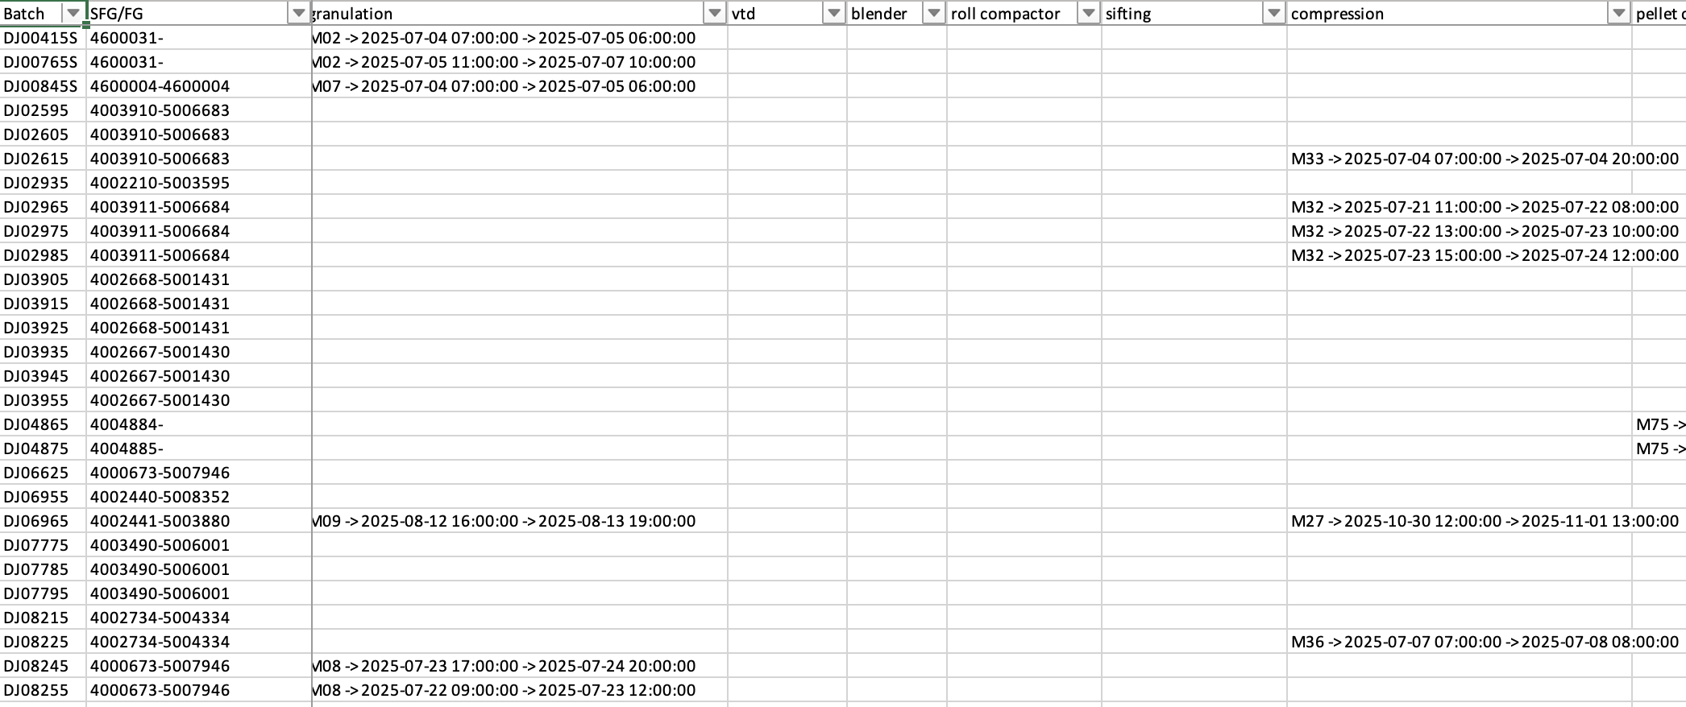
Pivot the path and step parquet generated by scheduler
Export the output as XLSX and apply conditional formatting

SPIMACO
Config file has all the paths defined
Masters:
- Capacity & CO Times (CapacityCalendar.XLSX): This shows the machine wise capacity and change over times.
- Routing Master (Sheet “Current Routes” in “MTO_Master_Template.XLSX”):
This is the routing master with touch times
- Stage Completion Mapping (Basic Operation text_mapping.csv):
this file contains the mapping of stages in scheduler / machine master with the status coming in SFO file

Input:
- PO_MAPPING<date>.txt: (on FTP server) Mapping file for SFG to FG
- PROCESS_ORDERS<date>.txt: (on FTP server) All the processed orders in SAP
- SFO_Overview<date>.csv: (on FTP server) WIP status of all batches already in production
- BMReport.parquet: Dataframe generated from VFlow (System1) containing color priority
- ProcessOrders.parquet: Dataframe generated from VFlow (System2) containing routes assigned. Select orders from “PROCESS_ORDERS<date>.txt” only if they have route assigned

Path Configuration (SpimacoConfig.py)
All the PATHS for files are defined here.

Fetching Input data from VFlow (Spimaco/ spimaco_db.py):
Get the BPP and assigned routes from VFlow for priority.

Fetching Input data from FTP (Spimaco/ spimaco_FTP.py):
Fetch the Input and Master files from FTP server.

Input data processing (Spimaco/ProcessInputs.py):
Check if input and master data is available. If no, abort
Here we capture all inputs and generate JSON/parquet files for Scheduler
There are two functions here:
The reason for these two functions is, the capacity master may be uploaded and validated separately.
- Validate the CO and Capacity Master file.
- Process All inputs
- Validate the CO and Capacity Master file (Function: validateCoAndCapacity):
Here we read the Capacity Master, check for duplicate columns and save the same as parquet file for Scheuler to populate the slots
- Process Inputs (Function: processSpimacoInputs)
  - Generate the Json for workstation and machines (generateWSMasterJson)
Read the parquet file generated in validateCoAndCapacity
Use the first 5 rows. Generate the machine and workstations ID’s
  - Read ALL process orders and drop blank rows and cleanup up invalid data
  - Drop the rows with TECO flag (completed)
  - Cleanup the TargetQty and Delivery Qty. Pending QTY is diff of two. If pending qty < 10 then we consider the orders as COMPLETE
  - Read the VFlow PO parquet file that contains route. Keep the orders that have route
  - Read the PO Mapping and cleanup. Remove duplicates and update the order DF with mapping
  - Read routing master, pick up only required columns and convert numeric columns for touch times, drop duplicates and validate data for different operations
  - Create a dict for sfg and fg routes
  - From the orders, drop the items with blank or invalid routes (e.g. >>>>)
  - Filter orders without route or BPP
  - Get the WIP status (like trailing dept in AjantaDHJ) – “getWipStatus” and remove the completed orders
  - Assign the category (3 buckets) – Black/Red, Yellow, Green/White/Blue
  - Sort the df as per category, priority etc
  - Generate the JSON for jobs.
  - There are NO interstage buffers so leave a blank buffers JSON

Scheduling (Spimaco/Spimaco_Scheduler_v1.py):
Here are the steps (starting with spimacoGoForIt function called from main)
- Check if mandatory files exist – if no, abort
- In function ‘spimacoGoForIt’, create instance of SpimacoDataImporter
Import the JSON files and the calendar parquet, Populate list of jobs and machines
- Instantiate Spimaco specific scheduler.
Generate the hourly slots and available paths for each job in a dataframe
  - Start date as today
  - Horizon is not required as the capacity calendar will define this
- Schedule jobs using “schedule_jobs” (from core scheduler)
This function calls orchestrator _schedule_jobs_pre_post) category by category
- Orchestrate jobs using “_schedule_jobs_pre_post” – as there is no FREE GAP requirement, it will be single pass (even though the function is generic)
- We use the generic function “_schedule_upstream_downstream” to identify the slots and book the slots
- Export the parquet files for report generation (and excel files for debugging)

Report Generation (Spimaco/genReport.py):
Here we generate following outputs
- Final Calendar Schedule
- Batch wise summary
- All PATH & STEP details (for debugging only)

Final Calendar Schedule
Read the scheduler generated output (FinalSchedule.parquet)
- This contains machine ID’s as columns and hourly slot as Index
- Curate the data by replacing the text with readable stuff
  - E.g. extract the batch number from “occupied” slots
  - Replace 'Non-Working” with “*~~*” (for excel conditional formatting)
- We need to aggregate hourly slots to day wise. Here the entire hourly dataframe is converted to day wise output. All the duplicate entries will get convered to single.
- Add the machine names (in addition to the machine ID’s) at the top of dataframe
- Update the text in columns to the one specified. This is done in “updatePCO”
- Change TypeB to PCO and ignore typeA
- The Calendar OUTPUT is ready

Batch Wise Summary
This is how each batch moved between operations. Now it’s important to know the sequence of columns may not align perfectly. Here is an example
Route1: Granulation – Mixing – Compression – filling …
Route2: Mixing – Compression – 2nd Mixing – Coating …
It’s difficult to represent in unified column sequence. The required order of columns is defined in variable “_order”

Here we take the dataframe of paths and steps. Group and Pivot. Here is how the summary looks like


Pivot the path and step parquet generated by scheduler

Export the output as XLSX and apply conditional formatting

GLENMARK INDORE
Masters (all shared on email):
- Master (Multiple sheet in “Indore scheduling tool vol 4 June 30.xlsx”)
- NEW_BOM.csv – this is the BOM file used for finding common blend SFG’s

Input (all shared on email):
- Commit.xlsx – Comitted SFG’s

Path Configuration
TO DO – based on UI that will be developed.

Input data processing (GlenIndoreProcessInput.py):
Here we capture all inputs and generate JSON/parquet files for SchedulerHere are the steps
- Read the BOM file for plant I111, and filter the rows where “SFG Code” is 4 characters AND “RM/PM Mat. Code” is 4 characters
- Read the Commit file for plant = I111 and column AA > 0
- Based on DoFC, assign the category
  - Cat 1 = DoFC <= 35 or MTO
  - Cat 2 = 35 < DoFC <= 70 or EU
  - Cat 3 = DoFC <= 120
  - All others are ignored
- The SFG code in commit file with common blend / bilayer has multiple SFG codes separated by SLASH (/)
- Check the BOM for Level2 and Level3 SFG codes. These are feeding SFG’s
- Currently there is 1 to 1 batch mapping, means to create 1 batch of FG it needs 1 batch of SFG. If SFG has feeding SFG then 1 batch of feeding SFG is required and so on.
- Within a category there can be only SINGLE FG/SFG entry
Note: This assumption can changes any time.
- Import Master Data:
  - From sheet “Machine master & CO Time”, read the machine details.
  - From sheet “Product-Turret-Swab-Blend”, read the turret details and swab details
  - Sheet (note the space at end) “Routemap database ” has all the routes
Validate if the specified machine has valid touchtime, If no, show error and skip the route.
If the machine in route is NOT defined in machine master, show error and skip the route.
- If there are feeding SFG’s at level2 and level3, the routes for this is defined in sheet “Common Blend Routes”. Apply the same logic as in point above
- Merge the routes with committed batches. If any batches have missing routes, flag the error and ignore the batches
- Define jobs (unique entity used by Scheduler) as follows:
FG is a separate job
SFG’s at level 1 is separate job (FG jobs depends on this SFG jobs)
SFG at level 2 is separate job (L1 SFG job depends on this SFG jobs)
SFG at level 3is separate job (L2 SFG job depends on this SFG jobs)
- Generate the Json for jobs, workstation and machines
TODO: Split the committed batches into campaigns as defined by MAX_BATCH_SIZE (=10 for now)
- TODO: There are NO interstage buffers so create a blank buffers JSON
- Export the campaign file

Scheduling (GlenmarkIndoreScheduler.py):
Here are the steps (starting from main)
- TODO: Check if mandatory files exist – if no, abort
- create instance of GlenmarkIndoreDataImporter
Import the JSON files, Populate list of jobs and machines
- Instantiate Indore specific scheduler (GlenmarkIndoreScheduler).
Update the list of holidays (ask consultants)
Update the list of weekends (ask consultants, currently Sunday)
Update the total scheduling horizon (ask consultants, currently 90 days)
- Generate the hourly slots and available paths for each job in a dataframe
  - Start date as today
  - As Capacity calendar is not provided, create hourly slots based on holidays and weekends. TODO: This can be moved to Importer to create calendar.parquet (like in case of Ajanta and SPIMACO)
  - As there is no WIP data, we need to assume some starting load on each workcenter / operation. E.g. Compression has 5 days of load
Ask consultants what load they want for each workcenter.
- We start with bottleneck scheduling (Compression and Granulation)
We call “schedule_jobs” with option preStageOnCCRs=True
This will pick 1 machine from the specified options based on the load on the machine from the committed batches where ONLY ONE option is available.
- Export the data so that bottleneck details can be shared via reports
- reInit the scheduler as we had earlier done only for bottleneck operations
- Schedule jobs using “schedule_opt1”
This function calls orchestrator “_orchestrate_opt1”) category by category
First we do the SFG’s and then FG’s
- “_orchestrate_opt1” takes the jobs in the category
This is a multi-pass scenario using FREE SLOT concept.
We use the generic function “_schedule_upstream_downstream” to identify the slots and book the slots
- Export the parquet files for report generation (and excel files for debugging)

Report Generation (***** PENDING *****.py):
Here we generate following outputs
- Final Calendar Schedule
- Batch wise summary
- All PATH & STEP details (for debugging only)

Final Calendar Schedule
Read the scheduler generated output (FinalSchedule.parquet)
- This contains machine ID’s as columns and hourly slot as Index
- Curate the data by replacing the text with readable stuff
  - E.g. extract the batch number from “occupied” slots
  - Replace 'Non-Working” with “*~~*” (for excel conditional formatting)
- We need to aggregate hourly slots to day wise. Here the entire hourly dataframe is converted to day wise output. All the duplicate entries will get convered to single.
- Add the machine names (in addition to the machine ID’s) at the top of dataframe
- Update the text in columns to the one specified. This is done in “updatePCO”
- Change TypeB to PCO and ignore typeA
- The Calendar OUTPUT is ready

Batch Wise Summary
This is how each batch moved between operations. Now it’s important to know the sequence of columns may not align perfectly. Here is an example
Route1: Granulation – Mixing – Compression – filling …
Route2: Mixing – Compression – 2nd Mixing – Coating …
It’s difficult to represent in unified column sequence. The required order of columns is defined in variable “_order”

Here we take the dataframe of paths and steps. Group and Pivot. Here is how the summary looks like


Pivot the path and step parquet generated by scheduler

Export the output as XLSX and apply conditional formatting

